This is to demo the functions and feature of each web page for the IOT Rexlite project written in ASP.NET /C#. This is the UI/UX Front-End design and JavaScript AJAX functions demo only. There are 15 web page in total (html with JavaScript and jQuery embedded) :

1. **ADSLSettings.html**

This is to demo the JavaScript Accordion design and features, and the text box validations. The Accordion box on the right hand side has collapsible headers so that you can go toggle between hiding and showing content. In order to test the textbox validations, for example, if you leave the User Name field empty, you will get an inline message reminder shown as the below screenshot. Upon entering text in the text box, the placeholder text will raise to the top and leave the text box as a blank field. In addition, you can click the eye icon on the very right side of the Password field to either show or hide the password you entered.

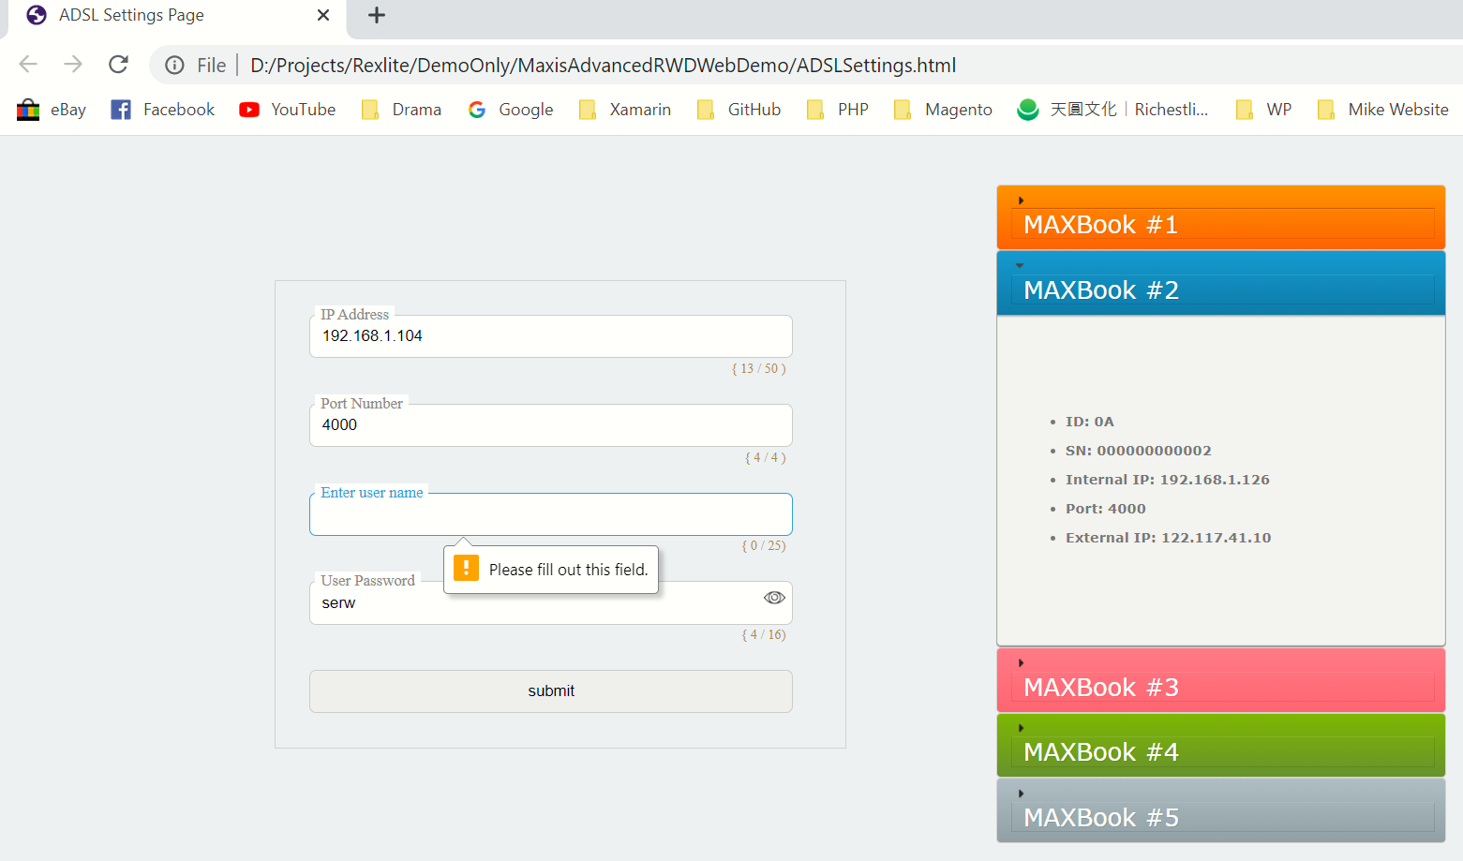

1. **DeviceIDSettings.html**

On the left-hand side of this web page, there are six square box showing available IOT switch device status. If the device is detected and available, then it will lit up and become golden, otherwise it will be dark. On the right-hand side, user can click on any Item’s label box and the number of the label currently being clicked will immediately shown on the top. So, this is one of interactive (RWD) JavaScript example.

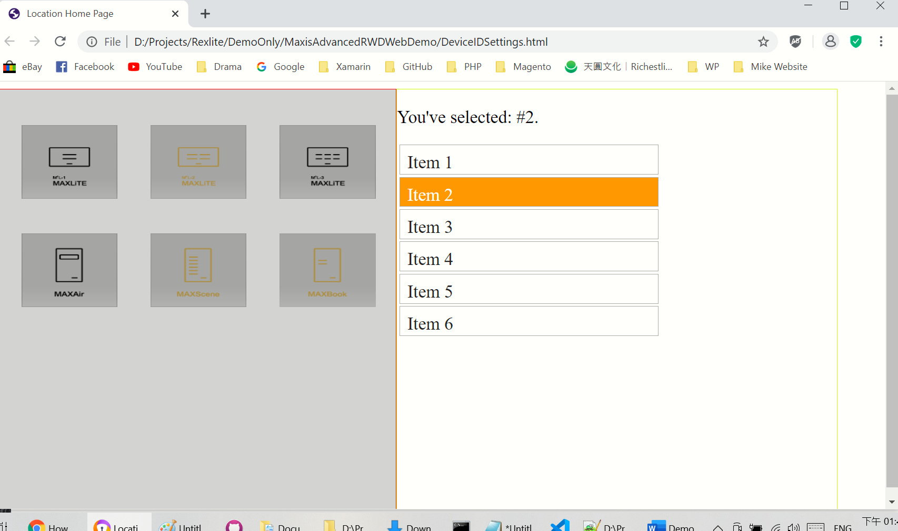

1. **index001-newDesign.html**

This shows six default IOT Device being dynamically detected by a passing Json array and find the matching device number. If found, the image will lit up and turned golden, otherwise it’s dark. Click on the any available device will get a confirmed popup message saying that device image is being clicked. No popup message will come out if click on any unavailable device image.

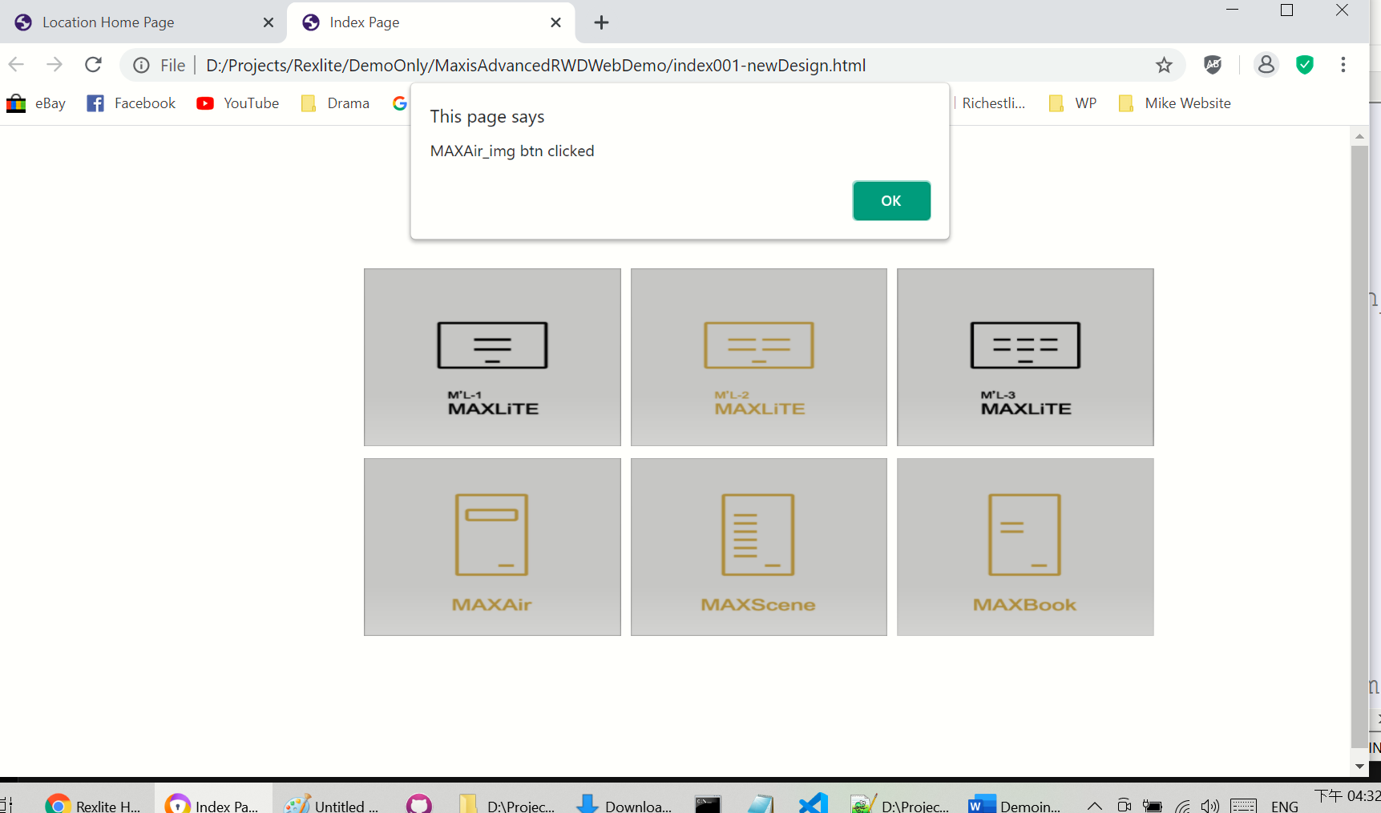

1. **LocationDeviceMain.html**

Click on the upper left corner icon will display a dropdown box, which are written in Chinese because my client was in Taiwan and they only used Chinese. However, these six device boxes are working like #3, but by clicking on the MaxLite3 icon (encircled by red border line), it will be redirecting to the **MAXLite3Main.html** which you will see on #12.

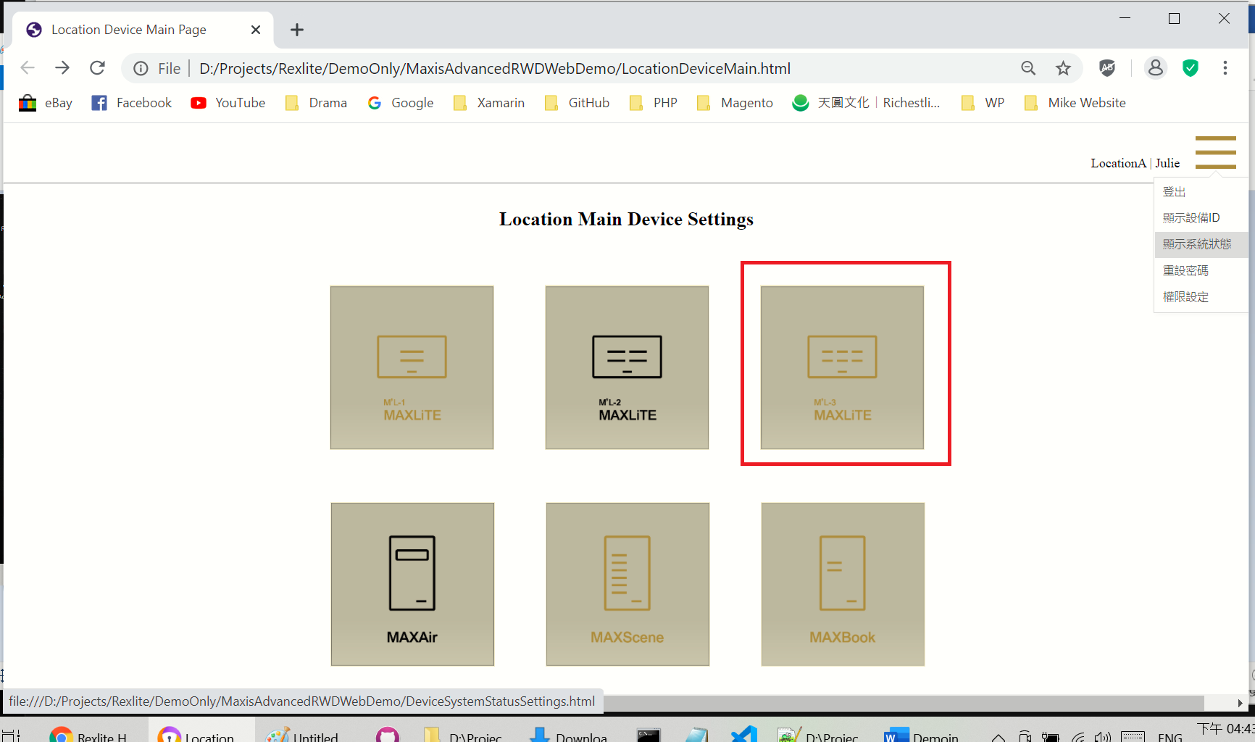

1. **LocationSettings.html**

This is to demo the how to dynamically create a new location box by clicking the “Add Location” button. This is not yet 100% complete. If it’s 100% complete, then by clicking more than 5 times, the new location box will be place on a new row below the first row, etc. Also, the update location text box below each main location box is not working 100% correctly. The first one won’t be updated correctly, but starting from the second location box the new location text will be shown correctly. The upper left corner dropdown box is working as same as #4.

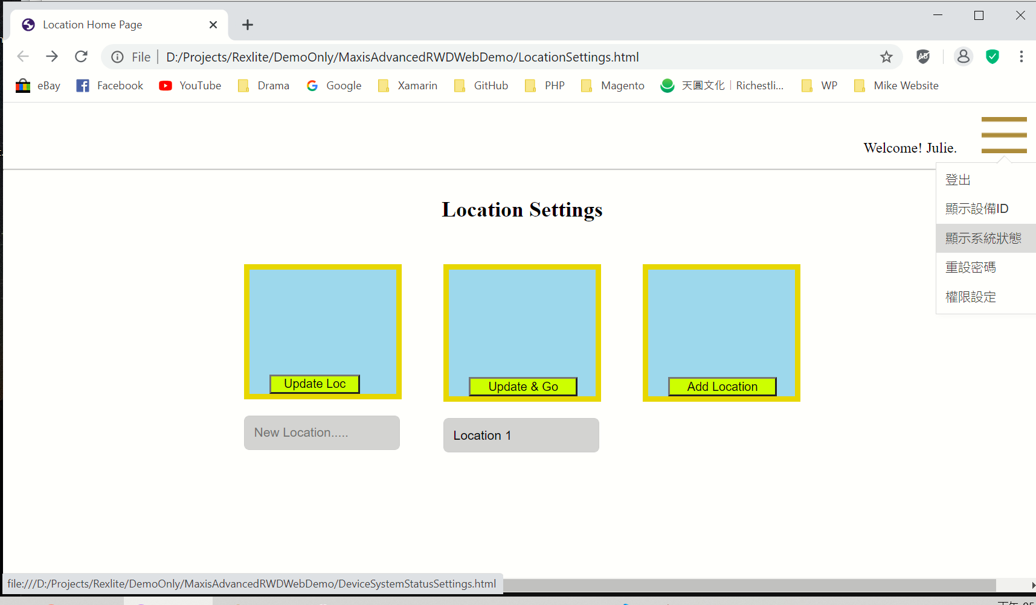

1. **Login.html**

JavaScript validation functions demo. Maximum length on each text box entry is 16 alphabets, so the entry will stop at 16th character and won’t go on. The total length of text entry will be shown simultaneously below the textbox (see the text encircled by the red border lines).

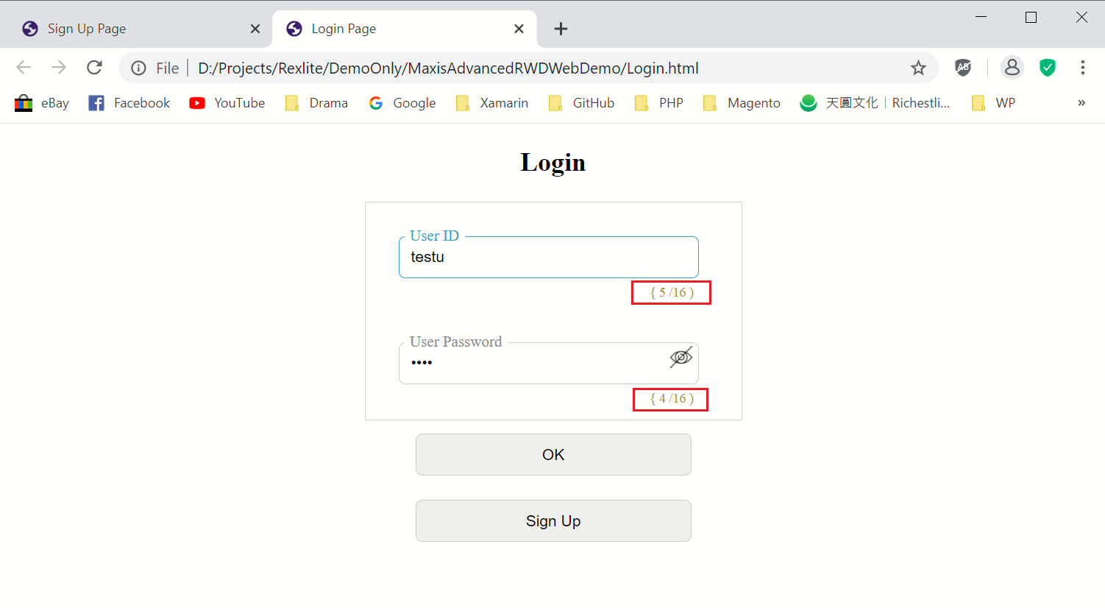

1. **MAXAirKeyPanel004.html**

This web page is to show the Air Conditioner Settings Panel design (html only, no functions). The Chinese title is “Living Room Air Conditioner”. The top row displays two temperature scale in Celsius and Fahrenheit units. The bottom row displays the Temperature Settings for current temperature and the timing settings (such as remaining time, etc.) In the footer, there are icons for Settings, Timing, Strength (temperature), Outdoor Temperature, Sleep Mode (from left to right in sequence).

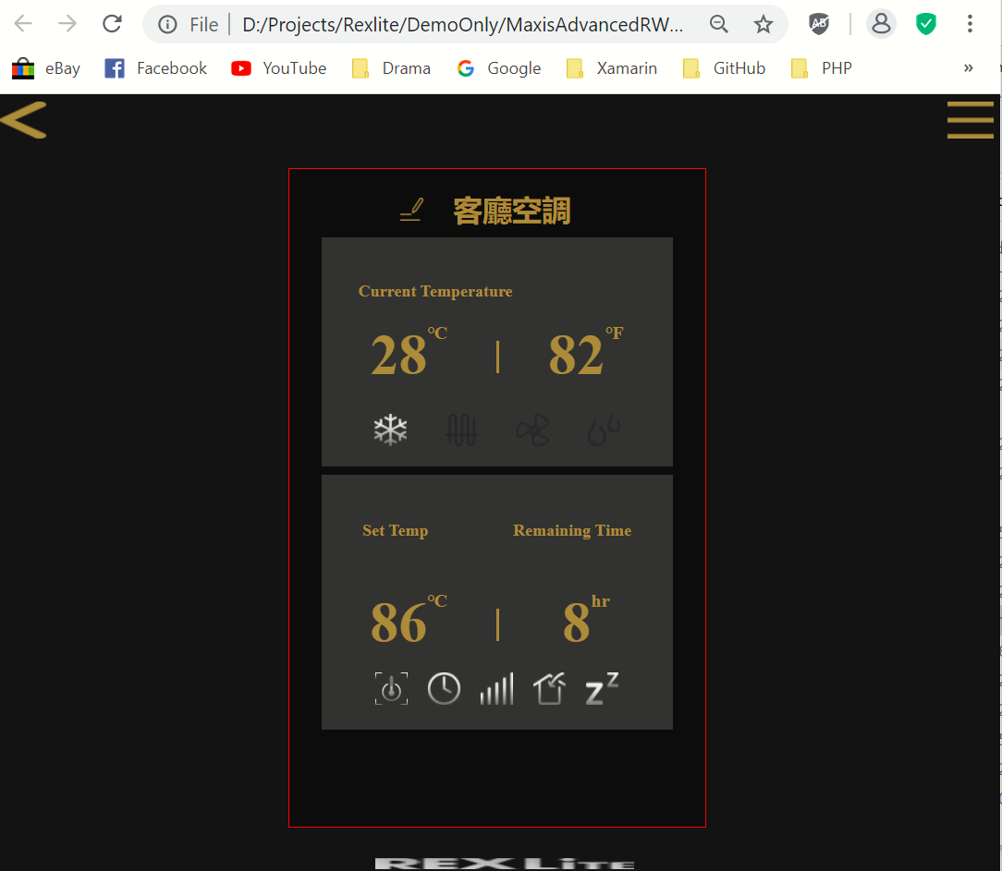

1. **MaxAirKeyPanelSlider001f.html**

This is a more advanced version of #7. Here is showing the fan icon in the top row. On the bottom there is a progress slider bar which you can drag and slide. And the slide is 10 increments by default, which means it will show only 10%, 20%, 30%, 40%,…..100%, This is designed for user to manually adjust the temperature, fan speed, timing, etc. by simply adjust the slider.

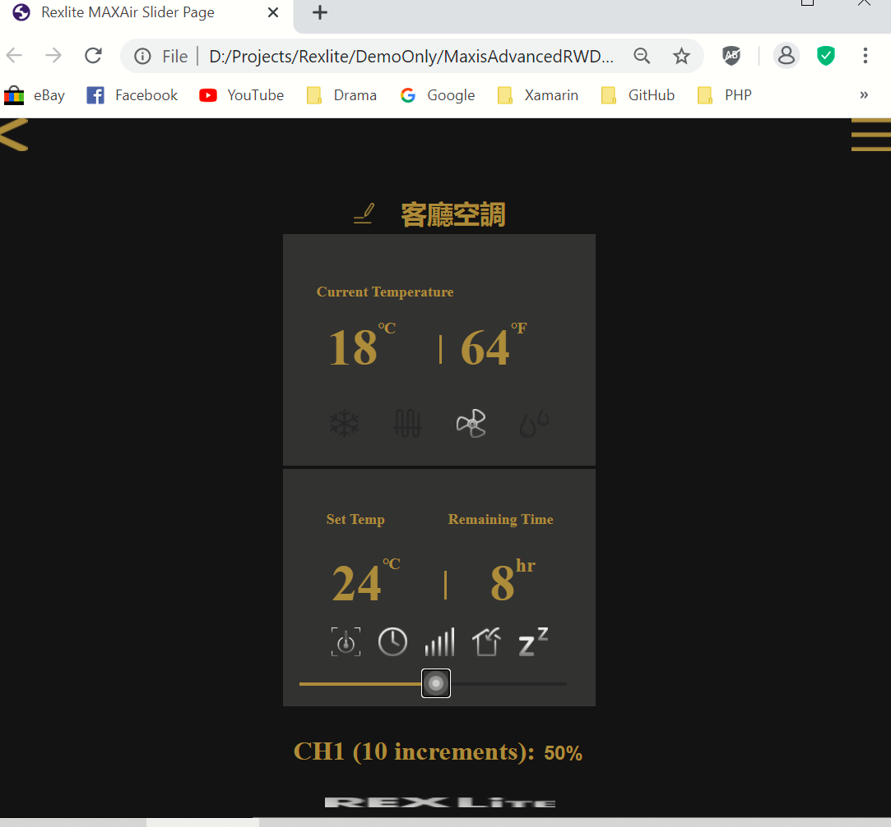

1. **MaxisDeviceListBySelectionDemo001-CreateButtonsInSequence.html**

www

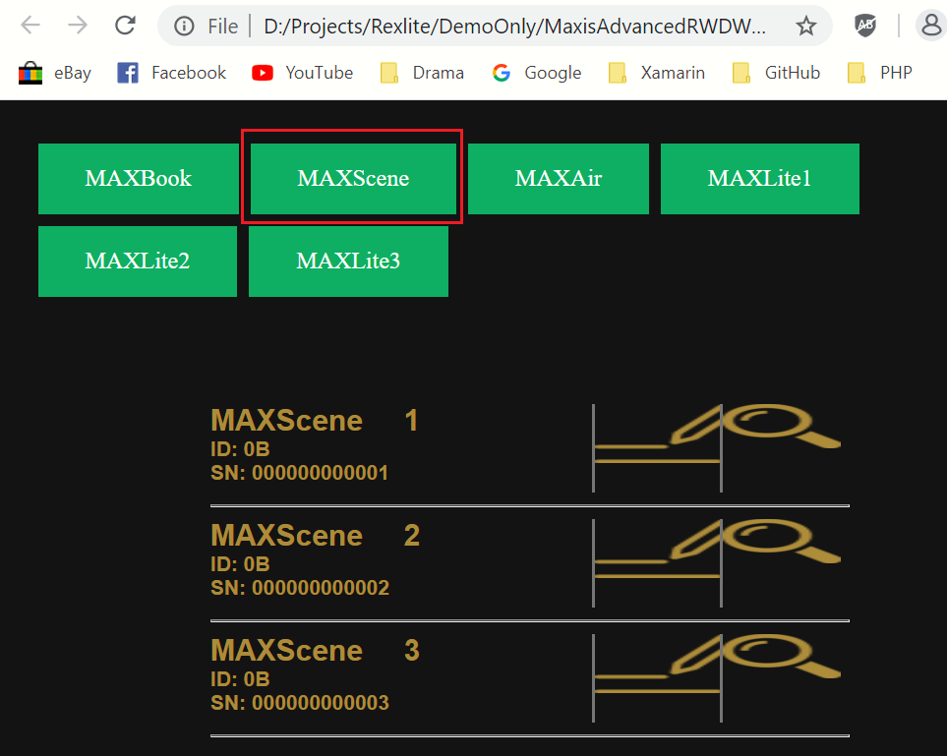

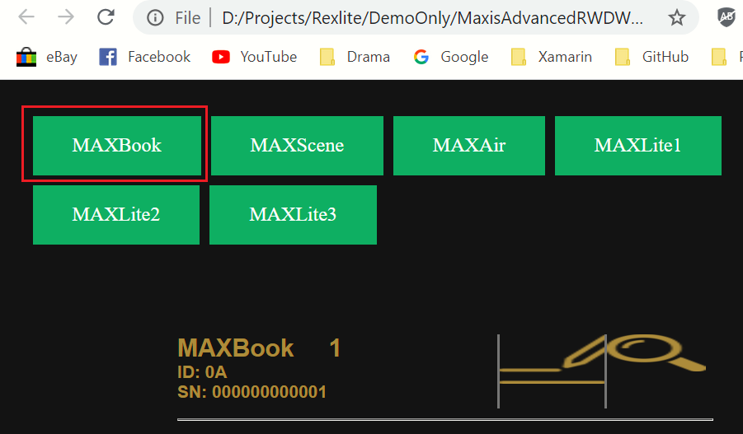

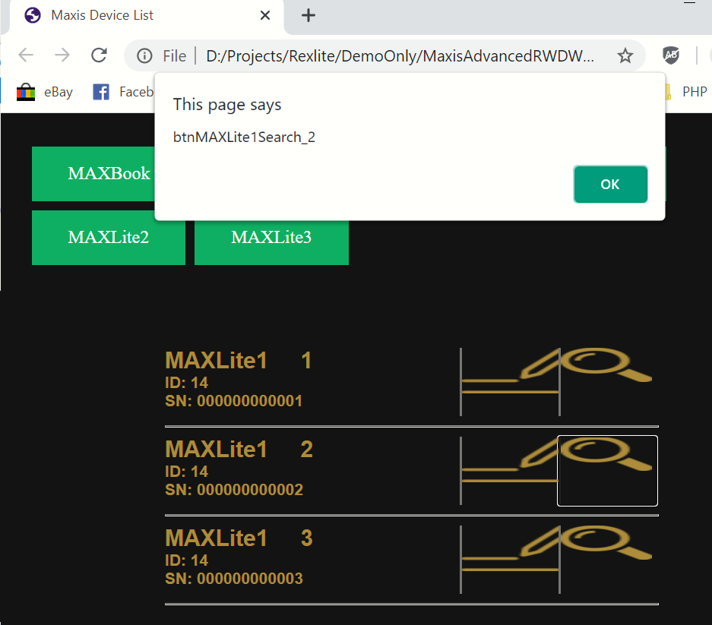

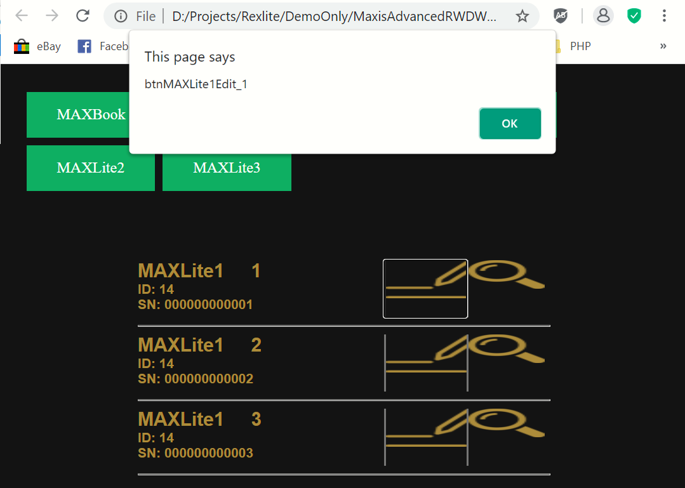

1. **MAXLite3DeviceSettings.html**

wwww

1. **Maxlite3KeyPanel_Basic.html**

wwww

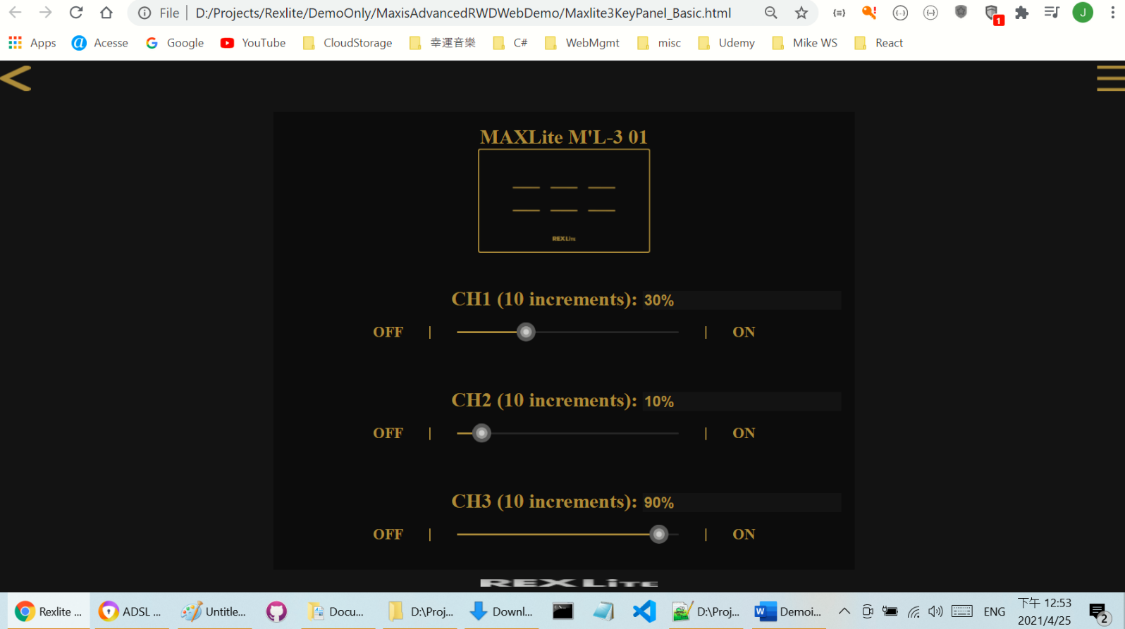

1. **MAXLite3Main.html**

wwww

1. **ModalWindow003-firstSuccessfulModalUpdateDeviceName.html**

wwww

1. **ResetPassword.html**

wwww

1. **SignUp.html**

wwww